**SUKRACHARYA**

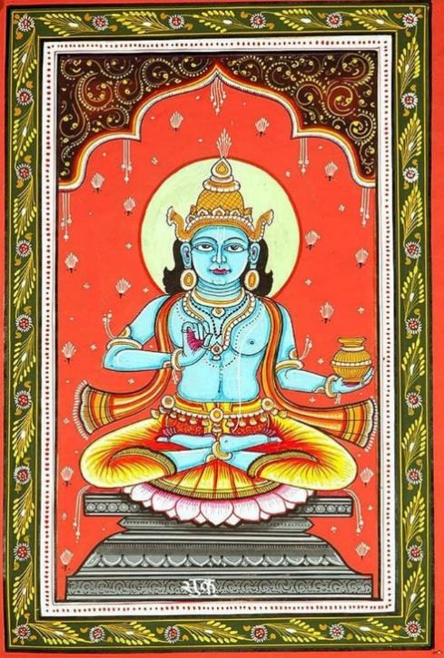

Shukracharya was the son of sage Bhrigu and nephew of bhakt prahlad. Sage Brigu’s first wife was Khyati who was daughter of Daxa; they had two sons Dhata and Vidhata along with a daughter Laxmi. Sage married his daughter to lord Vishnu. Bhrigu had more sons among them one was named Ushna which is believed to be another name of Shukracharya.

**Becoming the Asur Guru**

As Ushna reached his adolescence he was sent to sage Angiras to acquire his teachings. Sage Angiras was one of the best of Brahma’s sons. Also, he had a son named Brihaspati. Bhrihaspati used to study with Shukracharya. Between them, Shukracharya was sharp-witted and edgile. But as Brihaspti was the son of Angiras, the sage was biased about him which itched shukracharya a lot. Enraged by this preferential treatment, Sukracharya associated himself with demons and became their Guru(teacher/guide) for which he is also called Asuracharya. On the other hand, Brihaspati became Guru to Devtas(gods).

### Getting the name Shukracharya

Once he duped Kuber and stole all his wealth. Gods complained about this to lord shiva. Enraged by this, Shiva gulped him. He resided in Shiva’s stomach for thousands of years till he realised his mistake and started doing penance to lord Shiva from within. Pleased by this, lord shiva exerted him in the form of Virya(Sperm) which is Shukranu. Because of this he is also called Rudra Putra(son of shiva) Shankaracharya.

### Mrit Sanjivani Vidya

As we know there were several Devasur Sangram (Battles between gods and demons). Shukracharya was fed up with the constant defeat of Asuras so he decided to do Tapasya(penance) to please lord Shiva. To do so, he took off to the forest. On this side, He left all Asuras under the safety of his mother. To leverage his absence, Indra attacked Asuras. But, KhyatiMata(Some say Kavyamata) stunned Indra. Lord Vishnu then came to rescue Indra and while countering her Vishnu ended up chopping her head off. When sage Bhrigu came to know about demise of his wife, he cursed Lord Vishnu that he will have to go through the pain of birth again and again.

Before this, Lord Vishnu’s avatars used to just appear out of nothing like Varah, Nrusinh and others. After this, he took birth as Lord Raama & Lord Krishna.

Coming back to Shukracharya, Lord Shiva gave him MritSanjeevani Vidya(Power of resurrection) which he then used for demons who had died in the war. This way he caused the victory of demons over gods.

### Kacha (sage) - WikipediaKacha & Sukracharya

### Shukracharya’s rival and DevGuru Brihaspati sent his son Kacha as a student to Shukracharya to learn MritSanjivani Vidya. Even being well aware of Kacha, Shukracharya admitted him as his pupil. Against his acceptance, demons got upset to have him learning this power. They repeatedly tried to kill Kacha but almost every time Devyani (daughter of Shukracharya) would save him.

Though, once asuras successfully killed kacha then they burned him and powdered his bones, mixed it with wine which they later served to Shukracharya. Unaware about this, Shukracharya tried to resurrect Kacha and called for him. But this time the voice of Kacha came from his own gut. Kacha came out, ripping Shukrcharya’s stomach open. But, he had learnt MritSanjivani Vidya by then; so he resurrected Shukracharya before leaving to join Devtas. Which ultimately balanced both sides and helped Devtas win the war.

**His Famous Students**

1. Kacha: The son of Brihaspati, the rival of Shukracharya. Kacha won Shukracharya's trust and ultimately succeeded in learning the art of resurruction from Shukracharya.
2. Vrishaparva: King of the [Asuras](http://www.hindupedia.com/en/Asuras" \o "Asuras) and father of Sharmishtha, the ancestress of the Pandavas and the Kauravas
3. Prahlada: Devotee of Vishnu and the most powerful King of the [Asuras](http://www.hindupedia.com/en/Asuras" \o "Asuras)
4. Bali: Grandson of Prahlada, King of Asuras and a devotee of Vishnu
5. [Danda](http://www.hindupedia.com/en/Danda" \o "Danda): The youngest and the most irresponsible son of King Ikshvaku of [Ayodhya](http://www.hindupedia.com/en/Ayodhya" \o "Ayodhya). Though he was obedient to Shukracharya, he was slain when he violated Shukra's daughter against her will. Hence his former kingdom turned into the [Dandaka](http://www.hindupedia.com/en/Dandaka" \o "Dandaka) forests.
6. Prithu: The first consecrated King and the first true Kshatriya.
7. Bhishma: The son of King Shantanu. He studied all branches of knowledge and statecraft from Shukracharya.

### Shukracharya’s eye

Once King Bali was doing a Yagya where Lord Vishnu came in Vaman Avatar and asked for a promise to give him whatever he desired. Shukracharya recognised him and asked the king to refuse this demand. But the king did not comply with his advice and took a water vessel to take a swear. Thus, Shukracharya went and kept his one eye at the outlet of the water vessel. Vaman then tried to clean it with a grassblade which blinded Shukracharya. Hence, he is also known as Ekaksha.

2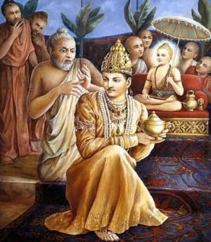

**Role in Mahabharata**

He had two wives Jayanti and Gow. As per Matsya Purana he is white skinned and rides a chariot with 8 horses as he holds Aayudh Dunda as weapon.He wears a crown with a neckles and sits on a white lotus with his four hands. Shukracharya carries Dunda, Rudraxmala, Patr(vessel) and have Varadmudra on one of his hands

As per Mahabharata he is master of Rasa, Mantra, and Medicines. He dedicated his entire life doing penance which put him in the good book of lord Shiva. He gave up all his wealth to his demon pupils. Also, He is the founder of Shukra Niti; a book about political science.

He had sons Shund and Amarka who lived with Hiranyakashyap.

Shukra Planet is associated with Shukranu(sperm) which is associated with life. As a planet he helps in prospering entire universe. In the court of Brahma he participates as one of the planets. He also pacifies other planets who prevent rain. Thus  he aids in rejuvenating life on earth by rain.

## **Shukracharya Was A Musician And Poet**

Shukra also has the distinction of being the best musician and poet. According to the Bhagavata Purana, Bhrigu Rishi also had a son named Kavi, who became famous as Shukrachaarya later. According to the Mahabharata, Shukra is also the author of medicines, mantras, and juices. Their strength is amazing. He gave all his wealth to his disciples’ Asuras and accepted the ascetic life itself.

How Shukrachaarya got the name Shukracharyaa: In connection with how Shukracharyaa got the name of Shukra known as Kavi or Bhargava, it is mentioned in detail in Vamana Purana.

According to the story, when Lord Shankar swallows Shukrachaarya, then the poet (**Shukracharya**) in the stomach of Shankarji started praising Shankar Bhagwan, which pleased Shiva and allowed him to go out. When he wandered in the stomach of Mahadev for one divine year, but when he found no end, he again started praising Shiva. Then Lord Shankar laughed and said that you had become my son because of my stomach, so come out of my penis. From today you will be known by the name of Venus in all the pastures of the world. Bhargava appeared in Lord Shankar’s penis after obtaining Shukratva ever since the poet became famous as Shukra.

## **Shukracharya’s Temple**

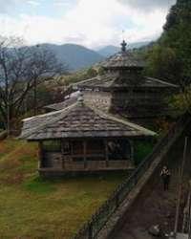

Many devotees thronged on the second Monday of Sawan for the worship of Shivalinga established by the demon Guru Shukracharya in Patna Devkali village of Kalan block in Shahjahanpur district. Extensive security arrangements have been made in the temple. A line of devotees has also been installed to ensure that everyone has the opportunity to worship equally. People from many districts come here to worship the Shivling established by the demon Guru Shukracharya. A big fair is organized.